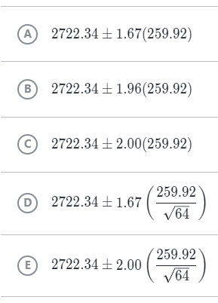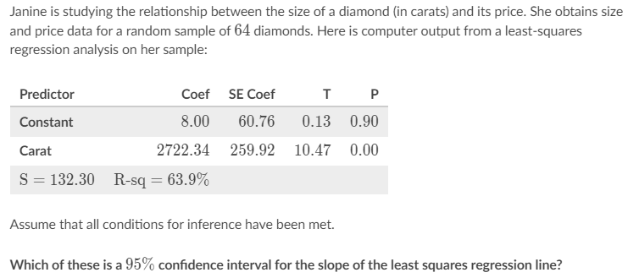

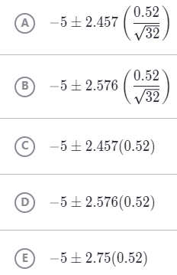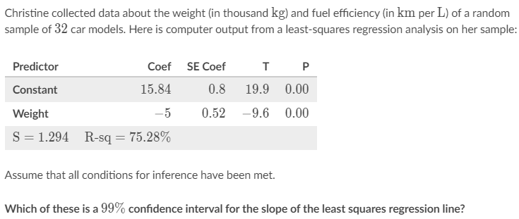

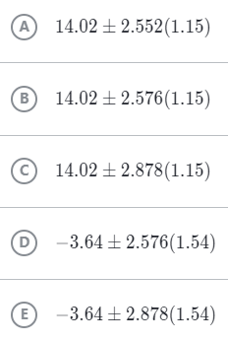

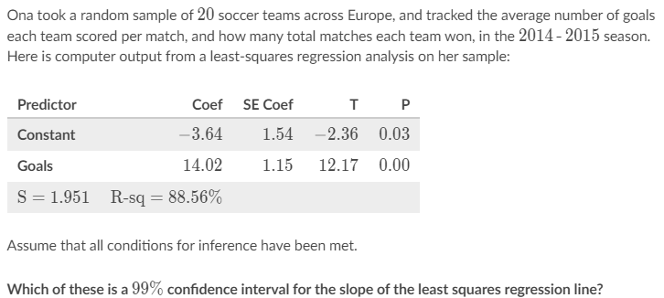

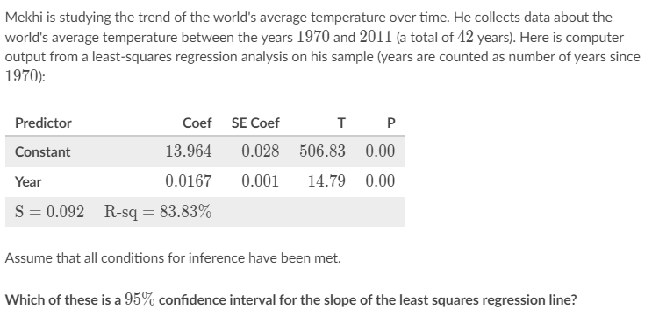

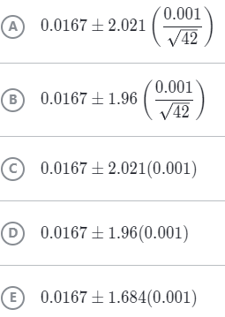

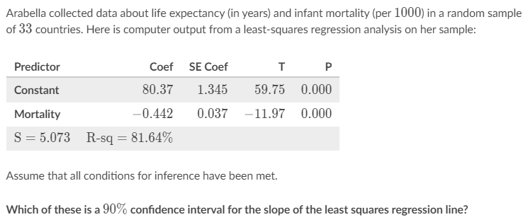

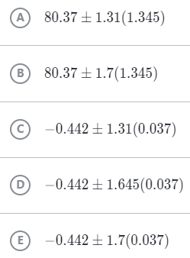

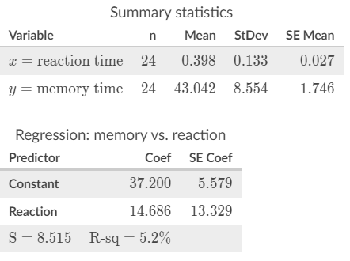Jian obtained a random sample of data on how long it took each of 24 students to complete a timed reaction game and a timed memory game. He noticed a positive linear relationship between the times on each task. Here is computer output on the sample data:

Assume that all conditions for inference have been met. Find an appropriate test statistic for testing the null hypothesis that the population slope in this setting is 0.

Nkechi took a random sample of 10 countries to study fertility rate (babies per woman) and life expectancy (in years). She noticed a negative linear relationship between those variables in the sample data. Here is regression output on the sample data:

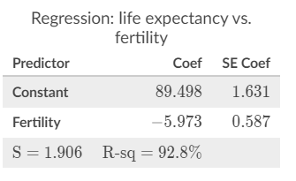Assume that all conditions for inference have been met.

Find an appropriate test statistic for testing the null hypothesis that the population slope in this setting is 0.

